**AR Map 2Go!**

**Software Requirement Specification**

By

**Mr. Parun Pichaiwong 522115043**

Department of Software Engineering

College of Arts, Media and Technology

Chiang Mai University

Project advisor

_________________________________

**Mr. Jayakrit Hirisajja**

**Document History**

|  |  |  |  |  |  |  |
| --- | --- | --- | --- | --- | --- | --- |
| **Document Name** | **Version** | **Status** | **Date** | **Viewable** | **Reviewer** | **Responsible** |
| **Documents** | | | | | | |
| **AR Map 2GO!_SRS_1.0a** | AR Map 2GO!_SRS   * SRS Outline * Introduction and Background * Feature | Initial Version | 18-06-2016 | PP, JH | PP | PP |
| **AR Map 2GO!_SRS_1.0b** | AR Map 2GO!_SRS   * Software scope * Functional Requirement * Use Case Diagram & Description * Requirement Specification | Reviewed | 24-06-2016 | PP, JH | PP | PP |
| **AR Map 2GO!_SRS_1.0c** | AR Map 2GO!_SRS   * Edit use case description * Activity diagram description | Reviewed | 04-07-2016 | PP, JH | PP | PP |
| **AR Map 2GO!_SRS_1.0d** | AR Map 2GO!_SRS  Added   * Update SRS | Reviewed | 15-07-2016 | PP, JH | PP | PP |
| **AR Map 2GO!_SRS_1.1** | AR Map 2GO!_SRS   * Update SRS | Reviewed | 05-08-2016 | PP, JH | PP | PP |

**\*PP = Parun Pichaiwong**

**\*JH = Jayakrit Hirisajja**

|  |  |  |  |  |  |  |
| --- | --- | --- | --- | --- | --- | --- |
| **AR Map 2GO!_SRS_1.0b** | AR Map 2GO!_SRS   * Software scope * Functional Requirement * Use Case Diagram & Description * Requirement Specification | Reviewed | 24-06-2016 | PP, JH | PP | PP |
| **AR Map 2GO!_SRS_1.2** | AR Map 2GO!_SRS  Update   * Use case Description   Update   * Project Constraint * SRS * Requirement Specification | Reviewed | 06-09-2016 | PP, JH | PP | PP |

**\*PP = Parun Pichaiwong**

**\*JH = Jayakrit Hirisajja**

**Table of Contents**

**1.1 Purpose** 4

**1.2 Software Scope** 4

**1.3 Operation Environment** 5

**1.4 Definition, Acronyms and Abbreviation** 5

**2.1 Product Perspective** 8

**2.2 Product Features** 8

**2.3 User Characteristics** 10

**2.4 Target Sources** 10

**2.5 User Requirements Specification** 11

**2.6 System Requirements Specification** 11

**2.7 Constraint** 15

**3.1 Use Case Diagram** 16

**4.1 System Requirement Specification** 19

Chapter One | Introduction

**1.1 Purpose**

The purpose of this document (Software Requirement Specification: SRS) is use to describe the functional requirement. The functional requirement is based on the researching of current problem and current solution. The requirements in this document are involved the stakeholders and users to use the system. This document is provided for the users and developers to explicit understand the detail of each requirement. In addition, the SRS document is used in the software design phase, which is lead to consistent of software product and functional requirement.

**1.2 Software Scope**

The scope of software has controlled by the user requirements. The software developed in the form of mobile application integrating with Augmented Reality technology and the web service.

The main features of software have 5 features;

* Registration and Authorization Management
* Web-Application and server Management
* Augmented Reality Management
* Map and Navigation Management
* Notification Management

The user should register before operating the activity in the system by using user email address as a username. After registration, the user information will send to the server for creating the new user account in the server database. The user can be interacting with the common features which provide by the application.

The system operates by scanning the specified picture (e.g. map shape) and location text title by using mobile camera view via this application. After that, the system will display all related Point of Interest (POI) locations in term of interactive 3D-object, create and operate with **Augmented Reality** technology, to the user. The user can touch on each 3D-object to get an action e.g. showing the location information or start navigating the user to the target destination.

The administrator will manage the data and information on the server side via the web application by adding a new location and new 3D object symbol into the server database to keep this application are newly and up-to-date.

**1.3 Operation Environment**

AR Map 2 Go2! is developing in form of mobile application. This application needs an Android operating system version 2.3.3(Gingerbread) and API 11 or higher because of the function of database system, Google API v.2.1 and application widget require. The user must have smartphone that is an Android operating system for running this application. This application requires the internet connection while using. Therefore, it is suitable and high mobility for mobile devices to run the system.

**1.4 Definition, Acronyms and Abbreviation**

1.4.1 Key Definition Key Definition

|  |  |
| --- | --- |
| IEEE | Institute for Electrical and Electronics Engineers. Biggest global interest group for engineers of different branches and for computer scientists. [IEEE90] |
| Augmented reality | Augmented reality (AR) is a live, copy, view of a physical, real-world environment whose elements are augmented (or supplemented) by computer-generated sensory input such as sound, video, graphics or GPS data. |
| Requirement | A condition or capability needed by a user to solve a problem or achieve an objective. A condition or capability that must be met or possessed by a system or system component to satisfy a contract, standard, specification, or other formally imposed document. A documented representation of a condition or capability as in definition  (1) or (2). [IEEE90] |
| Feature | Transformation of input parameters to output parameters based on a specified algorithm. It describes the functionality of a product in the language of the product. Used for requirements analysis, design, coding, testing or maintenance. [IEEE90] |
| Use Case | Concept to describe a system based on usage of system resources by its environment. Characterized by an objective-set of interactions within and at the borders of that system. Notation from UML for describing a scenario (Usage approach, operational scenario) from the perspective of tis users. [IEEE90] |
| Web Application | A computer software application that is coded in a browser-supported and reliant on a common web browser to render the application executable. |
| Software Engineering | The application of a systematic, disciplined, quantifiable approach to the development, operation, and maintenance of software; that is, the application of engineering to software.” [IEEE90] |
| Specification | Precise description of an activity or work product which serves as basis or input for further activities or work product. A specification can comprise requirements to a product and how they will be solved. Different parts of a specification (e.g., what is to be done, how it will be done) must not be mixed. [IEEE90] |
| Server | “a computer program running to serve the requests of other programs, the "clients". Thus, the "server" performs some computational task on behalf of "clients". The clients either run on the same computer or connect through the network. In most common use, server is a physical computer (a computer hardware system) dedicated to running one or more such services (as a host), to serve the needs of users of the other computers on the network. Depending on the computing service that it offers it could be a database server, file server, mail server, print server, web server, or some other kind of server.” |

1.4.2 Key Definition Key Definition

| KEY | ABBREVIATIONS |
| --- | --- |
| VSE | Very Small Entity |
| IEEE | Institute of Electrical and Electronics Engineers Software |
| UML | Unified Modeling Language |
| SRS-XX | Software Requirement Specification number YY |
| URS-AXX | User Requirement Specification for Android application number XX |
| URS-WXX | User Requirement Specification for Web application number XX |
| AD-XXX | Activity Diagram number XX |
| UC-AXX | Use Case for Android application number XX |
| UC-WXX | Use Case for web application number XX |
| C0-XX | Constraints number XX |

Chapter Two | Overall Description & Requirement

**2.1 Product Perspective**

**AR Map 2Go!** is a mobile application project which developing base on **Android** Operating System. The system has integrated with basic features of Android mobile application, **Augmented Reality** Technology, Geo-location Service and Web Application. The system provides a feature to display an interactive 3D-object, operate via **Vuforia SDK**, to the user by scanning on the map shape picture or the text title. The system has a basic feature on navigation and location tracking via Google Play Service and native Google Map application on android to navigate the user to the target destination.

The user should register for using the common features which provide by the application. The system operates by scanning on the specified map shape or location text title via camera view and display the related interactive 3D-object to the user. The administrator manages the data and information on the server side via the web application by adding a new location and new 3D object symbol into the server database to keep this application are up-to-date.

**2.2 Product Features**

**Feature #1:** **Registration and Authorization Management**

**Description:** This features supports web-application management  system for administrator.

**Target: Users**

* The user can register a new account.
* The user can delete an account.
* The user can login to the system.
* The user can logout from the system.
* The user can recover the password.
* The user can view the user profile.
* The user can edit profile information.
* The user can change profile picture.

**Feature #2:** **Web-Application and server Management**

**Description:** This feature supports registration of users for using the system.

**Target: Administrator**

* The administrator can login into the web application system.
* The administrator can logout from the web application system.
* The Administrator can add the new location into the server.
* The Administrator can add the new 3D object symbol into the server.

**Feature #3:** **Augmented Reality Management**

**Description:** This features supports about Augmented Reality management to show the 3-dimension object on the map.

**Target: Users**

* The system can scan on the specified map picture.
* The system can scan on the specified text title.
* The system can show the 3D-object via camera view.
* The user can interact with 3D-object by click to get the action.

**Feature #4:** **Map and Navigation Management**

**Description:** This features supports map management system on mobile application.

**Target Users**

* Develop Map using Google Maps API.
* The user can click on each 3D-object to get route direction planning.
* The system can navigate route direction via Google Map application.
* The system can show nearby locations related with the specified target.

**Feature #5:** **Notification Management**

**Description:** This features supports map management system on mobile application.

**Target: Users**

* The system can send the notification to the user when the system has been updated.

**2.3 User Characteristics**

The target users are travelers (foreign and domestic traveler) or anyone who need to use the new kind of map application and easy to use to support on location tracking and navigation while traveling along Thailand.

***2.3.1 User***

These are the general users that did not register to the system.

***2.3.2 Member***

These are the people who have registered as a member. They can login to get an authorization and identity from the system. The system will allow member to use fully function in the application.

***2.3.3 Administrator***

These are the people who have registered as a administrator. They have a permission to management the web-application system to provide the new location information, new 3D object files, edit or update the data on the server side.

**2.4 Target Sources**

AR Map 2Go! use **Augmented Reality** Technology to present the interactive 3D object by scanning on the target media sources;

***2.4.1 Picture of map shape***

These are the picture contains map shape of each target province.

***2.4.2 Location title’s name***

These are the location title name as a text on the magazine or specified book guide.

**2.5 User Requirements Specification**

2.5.1 URS of member:

**URS-A01:** The user can register a new account. **URS-A02:** The user can delete an account. **URS-A03:** The user can login to the system.**URS-A04:** The user can logout from the system.**URS-A05:** The user can reset password. **URS-A06:** The user can view the user profile.**URS-A07:** The user can edit profile information.**URS-A08:** The user can change profile picture. **URS-A09:** The user can view all available map list from the server database via the application. **URS-A10:** The user can view all available location’s title list from the server database via the application. **URS-A11:** The user can select one of the specified map picture from the list to see more detail. **URS-A12:** The user can select one of the specified text title from the list to see more detail. **URS-A13:** The user can scan on specified map shape or specified text title to see the related 3-dimension object via the camera view.

2.5.2 URS of administrator:

**URS-W01:** Administrator can login into the web application on the server. **URS-W02:** Administrator can logout from the web application on the server. **URS-W03:** Administrator can add the new location information into the system.

**2.6 System Requirements Specification list**

**SRS-01:** System shall provide interface with Sign-In, Sign Up button on menu bar.

**SRS-02:** System shall provide Sign Up interface with register form to receive user information including user email address as a username, password, confirm-password and “Register” button.

**SRS-03:** System shall verify all information is completed.

**SRS-04:** System shall verify duplicate of username with the server database.

**SRS-05:** System shall verify the input email format that allow email format.

**SRS-06:** System shall verify a match between password and confirm-password.

**SRS-07:** System shall verify length of password which allow at least 6 characteristics.

**SRS-08:** System shall record all information into the server database.

**SRS-09:** System shall record all information into the build-in application database.

**SRS-10:** System shall provide error message “This field is required”.

**SRS-11:** System shall provide error message “Please enter at least 6 characteristic”.

**SRS-12:** System shall provide error message “Password and confirm password is not match”.

**SRS-13:** System shall provide error message “Username must be an Email address”.

**SRS-14:** System shall provide error message “Please enter a valid email address”.

**SRS-15:** System shall provide error message “Username is duplicate with the database”

**SRS-16:** System shall navigate to Home page for user.

**SRS-17:** System shall provide Interface to retrieve user information from the application database including ID, username, E-mail address, mobile phone, Facebook account, user address and profile picture, “Edit Profile” button, “Delete User Account” button.

**SRS-18.** System shall provide the pop-up dialog to ask the user to confirm deleting an account with “Accept” or “Cancel”.

**SRS-19.** System shall delete user account contains all of user information from the server database via matching user ID.

**SRS-20.** System shall delete user account contains all of user information from the application database.

**SRS-21:** System shall provide Sign-In interface with sign-in form to receive username, password, “Sign-In” button and “Reset Password” button to the user.

**SRS-22:** System shall verify username and password with the server database.

**SRS-23:** System shall verify username and password are completed.

**SRS-24:** The system gives the authorization and identity to the users.

**SRS-25:** System shall navigate to Main page for member including menu tab with available map scan list, available text scan list. Home button, Profile button, Augmented Reality button, Map button, Setting button and Search button.

**SRS-26:** System shall provide error message “Incorrect Username or Password”.

**SRS-27**: The system provides the interface that presents the “logout”

button.

**SRS-28.** System shall provide the pop-up dialog to ask the user to confirm logout an account with “Accept” or “Cancel”.

**SRS-29:** The system shall destroy user authorization.

**SRS-30:** The system shall update user status in server database.

**SRS-31:** System shall provide interface for reset password to receive username as an Email address and “Submit” button.

**SRS-32:** The system shall send the URL for create new password to user’s E-mail address.

**SRS-33**: System shall provide setting the new password page to receive a new password and confirm password.

**SRS-34:** System shall verify a new password and confirm password.

**SRS-35:** System shall update all new information into the server database.

**SRS-36:** System shows the message “Password has been reset”.

**SRS-37:** System shall navigate to profile page with retrieve the user ID, username, E-mail address, mobile phone, Facebook account, user address and profile picture from the database and show to the user on text field with profile page.

**SRS-38:** System shall navigate to an edit user profile page with retrieve the user information from the application database and allow the user to edit profile information on text field including with username, E-mail address, mobile phone, Facebook account and address and “Save” button.

**SRS-39:** System shall update information on the application database.

**SRS-40:** System shall return the message “Update successful”.

**SRS-41:** System shall provide interface to access mobile photo library. **SRS-42:**System shall resize the selected photo width and high into 150 x 150 (pixel x pixel). **SRS-43:**System shall set the selected image at image layout in Profile page to present as a profile picture. **SRS-44:** The system shall convert image file type from Bitmap or JPEG to BLOB type. **SRS-45:** The system shall store the new image file into the application database.

**SRS-46:** System shall connect the server database to retrieve the data of map information. **SRS-47:** System shall provide list-view of all available map information from the server database and present with map picture and map name. **SRS-48:** System shall connect the server database to retrieve the data of location text title. **SRS-49:** System shall provide list-view of all available location text title from the server database and present with location name. **SRS-50:** System shall provide the interface to display all related information of selected map including location name, specified map picture, scanning condition and help information. **SRS-51:** System shall provide the interface to display all related information of selected title including with location name, specified magazine or specified book that use for, scanning condition and help information in more detail. **SRS-52:** System shall provide the interface to scan the specified target. **SRS-53:** System shall verify map shape with the server database. **SRS-54:** System shall verify location text title with the server database. **SRS-55:** The system shall provide an asset folder in the application to provide .XML and .DAT files. **SRS-56:** The system shall render and generate 3-dimension and display the on the camera view. **SRS-57:** System shall provide Index page with login link on menu bar.

**SRS-58:** System shall provide login page with login form to receive username, password and login button to the user. **SRS-59:** System shall verify username and password with the server database. **SRS-60:** System shall verify username and password are completed. **SRS-61:** System shall provide error message “This field is required”. **SRS-62:** System shall provide error message “Login information is not valid”. **SRS-63:** System shall give an authorization for the user to administrator. **SRS-64:** System shall redirect to Home page for administrator that including menu tab of administrator Home, Management, Edit Profile, Location, Add Location. **SRS-65:** System shall provide Logout link on menu bar. **SRS-66:** System shall clear user session. **SRS-67:** System shall redirect to Index page for visitor. **SRS-68:** System shall provide forum button on profile menu and forums link on menu bar. **SRS-69:** System shall provide add new location forum to receive new location information as text field (Location Name, Description, Map ID, Location Status, Location Province, Location Text Title) and upload field (Location Map Picture as .jpeg or .png, Location Map 3D object file as .obj), brown and submit button. **SRS-70:** System shall verify input information (Location Name, Description, Map ID, Location Status, Location Province, Location Text Title) and upload field (Location Map Picture as .jpeg or .png, Location Map 3D object file as .obj) cannot empty. **SRS-71:** System shall record all information into the server database. **SRS-72:** System shall provide message “Add New Location Successful”.

**SRS-73:** System shall return to add new location forum page.

**2.7 Constraint**

**CO-01:** The system shall connect the Internet. **CO-02:** The application requires Android Operation System version 2.3.3 with Google API 17 or higher. **CO-03:** The users must have at less an account of email address for registration. **CO-04:** The application requires to open the service of GPS on the user mobile to access the user location. **CO-05:** The application requires Google Play Service to run the function on the Google map on mobile. **CO-06:** The application requires smartphone with Gyroscope sensor for using Augmented Reality feature. **CO-07:** The application requires the mobile internal storage to store the data and application media. **CO-08:** The limited of Augmented Reality using are the hardware specification and environmental constraints such as the ambient light, shape of picture, contrast & brightness

Chapter Three | Specific Requirement

**3.1 Use Case Diagram**

3.1.1 The Overview Use Case Diagram: User Side



**Figure 3.1:** The Overview Use Case Diagram: User Side - part 1



**Figure 3.2:** The Overview Use Case Diagram: User Side - part 2

From the **figure 3.1** and **3.2** is the overview use case diagram of the system of the user side. The use case diagram presents the entire functional requirement that an actor can do. In the figure, there are many kinds of functions that interact with the system. The functions depend on the user purpose. Also, all kinds of functions come from the general users.

3.1.2 The Overview Use Case Diagram: Administer side



**Figure 3.3:** Overview Use Case Diagram: Administrator side

From the **figure 3.3** is the overview use case diagram of the system of the administer side. The administer can interact with the system with the functions which only the administrator can use.

Chapter Four |Software Requirement Specification

**4.1 System Requirement Specification**

4.1.1 URS-A01: The user can register a new account.

|  |  |  |
| --- | --- | --- |
| **Use Case Element** | **Description** | |
| Use Case Number : | UC-A01 | |
| Use Case Name : | Register | |
| Use Case Description : | User must register to be a member by input require information to the system so, user will have member account to login to the system. | |
| Actor : | User | |
| Pre-Conditions : | - User’s status is a general user and they do not login to the system. | |
| Post Conditions : | - System shall record all information into the server database and the application database.  - User will have username as an email address and password for logging in | |
| Trigger : | - User clicks “Sign Up” button | |
| Normal Flow : | Visitor | System |
| 1. Clicks “Sign Up” button  3. User input all user information.  (username as an email address, password, confirm-password)  4. User clicks “Register” button | 2. System provide register page with register form  5. System shall verify the information  6. System shall record all information into the server database.  7. System shall record all information into the build-in application database.  8. System shows the message “Registration Successful”.  9. System shall navigate to Home page for user |
| Alternative Flow : | **5a. If user input username which are duplicate with the database.**  5.1 System shall provide error message “Email Exists!”.  **5b. If all information is not completed.**  5.2 System shall provide error message “**This field is required**” on each text field.  **5c. If data between password and re-password are not match.**  5.3. System shall provide error message “Password are not match”.  **5d. If user input username is not an email address.**  5.4. System shall provide error message “Username must be an Email address”.  **5e. If length of password which have at least 6 characteristic.**  5.5. System shall provide error message “Please enter at least 6 characteristic”.  **5f. If the input email format that is not email format.**  5.6. System shall provide error message “Please enter a valid email address”. | |
| Exception Flow : | - | |

**Table 1:** Present the data which used to input for creating new profile.

|  |  |  |
| --- | --- | --- |
| Data | Example | Note |
| Username | [parunn@hotmail.com](mailto:parunn@hotmail.com) | - length : 10 - 254 characters - format : email format |
| Password | Rtwe3dfa | - length : 6 - 15 characters  - use only : alphabet and number |
| Re-password | Rtwe3dfa |

**Process**

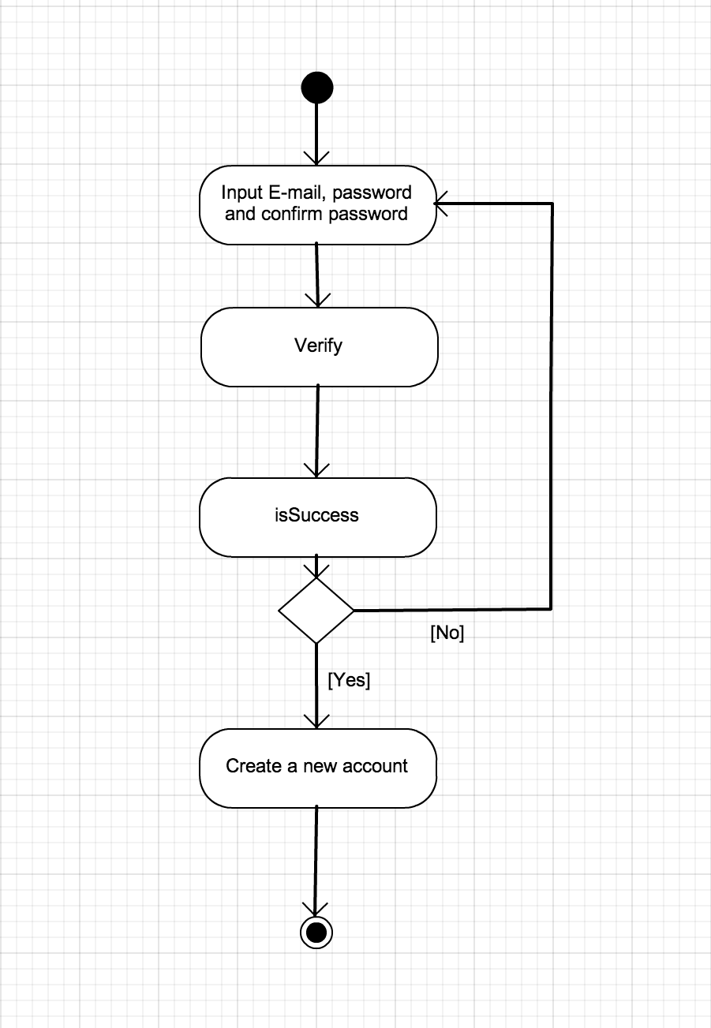

**Figure 4.1:** Activity Diagram of register a new account (AD-001)

The activity diagram from the **figure 4.1** presents the registration process. The users register with the system by receive user E-mail address, password and confirm password. The system will verify that the E-mail address already existed in the server database. Then verify matching between password and confirm password. If the process is success, System allows registering and create a user account and information into the database server. Also, the application will create a user account and information in SQLite database on mobile application.

**Software Requirement Specification**

**SRS-01:** System shall provide interface with Sign-In, Sign Up button on menu bar.

**SRS-02:** System shall provide Sign Up page with register form to receive user information (user email address as a username, password, confirm-password), and Register button.

**SRS-03:** System shall verify all information is completed.

**SRS-04:** System shall verify duplicate of username with the server database.

**SRS-05:** System shall verify the input email format that allow email format.

**SRS-06:** System shall verify a match between password and confirm-password.

**SRS-07:** System shall verify length of password which allow at least 6 characteristics.

**SRS-08:** System shall record all information into the server database.

**SRS-09:** System shall record all information into the build-in application database.

**SRS-10:** System shall provide error message “This field is required”.

**SRS-11:** System shall provide error message “Please enter at least 6 characteristic”.

**SRS-12:** System shall provide error message “Password and confirm password is not match”.

**SRS-13:** System shall provide error message “Username must be an Email address”.

**SRS-14:** System shall provide error message “Please enter a valid email address”.

**SRS-15:** System shall provide error message “Username is duplicate with the database”

**SRS-16:** System shall navigate to Home page for user.

4.1.2 URS-A02: The user can delete an account.

|  |  |  |
| --- | --- | --- |
| **Use Case Element** | **Description** | |
| Use Case Number : | UC-A02 | |
| Use Case Name : | Delete an account. | |
| Use Case Description : | Member can delete an account from the server database and application database. | |
| Actor : | Member | |
| Pre-Conditions : | - User already login to the system | |
| Post Conditions : | System shall delete an account from application database after delete account.  System shall delete an account from server database after delete account.  System shall navigate to Home page for user. | |
| Trigger : | User select Setting button on profile menu or Setting link on menu bar. | |
| Normal Flow : | Member | System |
| 1. Go to Edit Profile page.  3 Clicks “Delete User Account” button.  5. User clicks “Accept” button. | 2. System shall provide Interface to retrieve user information from the application database including ID, username, E-mail address, mobile phone, Facebook account, user address and profile picture, “Edit Profile” button, “Delete User Account” button.  4. System shall provide the pop-up dialog to ask the user to confirm deleting an account with “Accept” or “Cancel”.  6. System shall delete user account contains all of user information from the application database.  7. System shall delete user account contains all of user information from the server database via using user ID.  8. System shall delete user account contains all of user information from the server database via matching user ID. |
| Alternative Flow : | **5a. If user select Cancel button.**  5.1 System shall navigate to Edit Profile page for member. | |
| Exception Flow : |  | |

**Process**

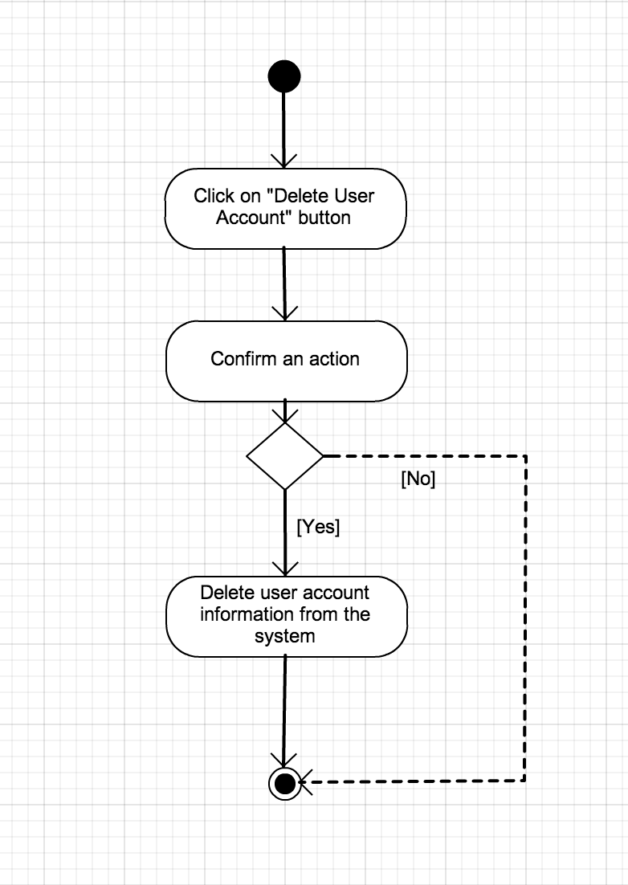

**Figure 4.2:** Activity Diagram of delete user account (AD-002)

The activity diagram from the **figure 4.2** presents delete user account process. User can delete the own account by click on “Delete User Account” Button. The system will ask the user to confirm to delete an account between “Accept” or “Cancel”. If user confirm to delete the account. The user account contains all of user account information will remove from both of server database and application database system. On the other hand, the action will cancel.

**Software Requirement Specification**

**SRS-17:** System shall provide Interface to retrieve user information from the application database including ID, username, E-mail address, mobile phone, Facebook account, user address and profile picture, “Edit Profile” button, “Delete User Account” button.

**SRS-18.** System shall provide the pop-up dialog to ask the user to confirm deleting an account with “Accept” or “Cancel”.

**SRS-19.** System shall delete user account contains all of user information from the server database via matching user ID.

**SRS-20.** System shall delete user account contains all of user information from the application database.

4.1.3 URS-A03: The user can login to the system.

|  |  |  |
| --- | --- | --- |
| **Use Case Element** | **Description** | |
| Use Case Number : | UC-A03 | |
| Use Case Name : | Login | |
| Use Case Description : | Member have to login to the system for using more feature that including edit their profile, scan the map image and location text title, map navigation and location tracking. | |
| Actor : | Member | |
| Pre-Conditions : | - User already have member account to login to the system | |
| Post Conditions : | - User can use more features in the system | |
| Trigger : | - User clicks “Sign In” button in Home page for user. | |
| Normal Flow : | Member | System |
| 1. Clicks Sign In Button  3. User input username and password.  4. User clicks “Sign In” button to submit. | 2. System shall provide sign in page with sign in form to receive username, password and sign in button to the user.  5. System shall verify username and password with server database.  6. System shall navigate to Main page for member. |
| Alternative Flow : | **5a. If username and password are not completed.**  5.1 System shall provide error message “This field is required”  **5b. If username and password are not match with database.**  5.2 System shall provide error message “Incorrect Username or Password”. | |
| Exception Flow : | - | |

**Table 2:** Present the data which used to input for login to the system.

|  |  |  |
| --- | --- | --- |
| Data | Example | Note |
| Username | [parun@hotmail.com](mailto:parun@hotmail.com) | - length : 10 - 254 characters  - format : email format |
| Password | parun15 | - length : 6 - 15 characters  - use only : alphabet or number |

**Process**

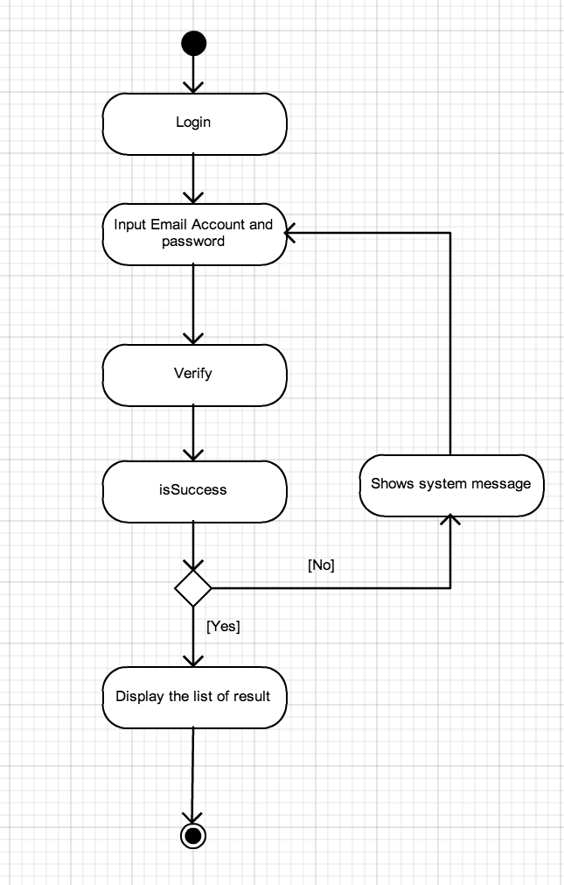

**Figure 4.3:** Activity Diagram of login to the system (AD-003)

The activity diagram from the **figure 4.3** presents the login process. The user can login via system account by inputting username and password. If login to the system successful, the system will give the user authorization.

**Software Requirement Specification**

**SRS-21:** System shall provide Sign-In interface with sign-in form to receive username, password, “Sign-In” button and “Reset Password” button to the user.

**SRS-22:** System shall verify username and password with the server database.

**SRS-23:** System shall verify username and password are completed.

**SRS-24:** The system gives the authorization and identity to the users.

**SRS-25:** System shall navigate to Main page for member including menu tab with available map scan list, available text scan list. Home button, Profile button, Augmented Reality button, Map button, Setting button and Search button.

**SRS-10:** System shall provide error message “This field is required”

**SRS-26:** System shall provide error message “Incorrect Username or Password”.

4.1.4 URS-A04: The user can logout from the system.

|  |  |  |
| --- | --- | --- |
| **Use Case Element** | **Description** | |
| Use Case Number : | UC-A04 | |
| Use Case Name : | Logout | |
| Use Case Description : | Member can logout from the system and return status to be user. | |
| Actor : | Member | |
| Pre-Conditions : | - User already login to the system | |
| Post Conditions : | System shall destroy user authorization and update user status in server database.  System shall navigate user to the Home page. | |
| Trigger : | - User clicks “Logout” button | |
| Normal Flow : | Member | System |
| 1. Clicks Logout button.  3. Clicks “Accept”. | 2. System shall provide the pop-up dialog to ask the user to confirm logout an account with “Accept” or “Cancel”.  4. System shall destroy user authorization.  5. System shall update user status in server database.  6. System shall navigate to Home page for user. |
| Alternative Flow : | **2a. If user select Cancel button.**  2.1 System shall navigate to Main page for member. | |
| Exception Flow : | - | |

**Process**

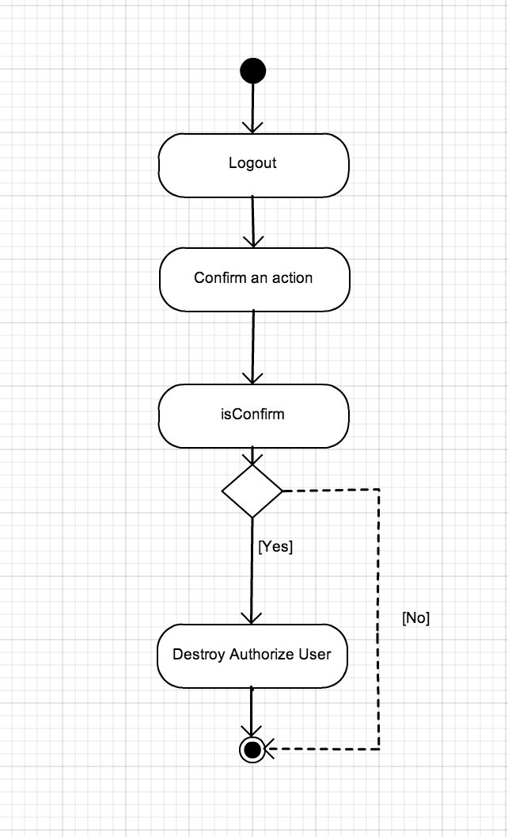

**Figure 4.4:** Activity Diagram of delete user account (AD-004)

The activity diagram from the **figure 4.4** presents the logout process. The users can click for logout from the system. The system will clear the user authorization.

**Software Requirement Specification**

**SRS-27**: System provides the interface that presents the “logout”

button.

**SRS-28.** System shall provide the pop-up dialog to ask the user to confirm logout an account with “Accept” or “Cancel”.

**SRS-29:** System shall destroy user authorization.

**SRS-30:** System shall update user status in server database.

**SRS-16:** System shall navigate to Home page for user.

4.1.5 URS-A05: The user can reset password.

|  |  |  |
| --- | --- | --- |
| **Use Case Element** | **Description** | |
| Use Case Number : | UC-A05 | |
| Use Case Name : | Reset Password | |
| Use Case Description : | Member can set a new password if they cannot remember the current password by input the registered E-mail address (username) to do this process. | |
| Actor : | Member | |
| Pre-Conditions : | - User already have member account to login to the system | |
| Post Conditions : | - User can reset password | |
| Trigger : | - Clicks “Reset Password” button in Home page for user. | |
| Normal Flow : | Member | System |
| 1. Clicks Reset Password Button.  3. User input the registered E-mail address (username).  4. User clicks “Submit” button to submit.  7. User open an E-mail address from the server and click on the URL to validate and confirm to start the process.  9. User input a new password and confirm password. | 2. System shall provide reset password page to receive username as an Email address to the user.  5. System shall verify username with server database.  6. The system shall send the URL for create new password to user’s E-mail address.  8. System shall provide setting the new password page to receive a new password and confirm password.  10. System shall verify a new password and confirm password.  11. System shall update all new information into the server database.  12. System shows the message “Password has been reset”.  13. System shall navigate to Home page for user |
| Alternative Flow : | **10a. If user input username which are not duplicate with the database.**  10.1 System shall provide error message “Email is not existing in the system”.  **10b. If the input email format that is not email format.**  10.2. System shall provide error message “Please enter a valid email address”.  **10c. If password and confirm password not match.**  10.3 System shall provide error message “Password are not match”. | |
| Exception Flow : | - | |

**Table 3:** Present the data which used to input for recover the password.

|  |  |  |
| --- | --- | --- |
| Data | Example | Note |
| E-Mail | [parun@hotmail.com](mailto:parun@hotmail.com) | - length : 10 - 254 characters  - format : email format |
| Password | parun15 | - length : 6 - 15 characters  - use only : alphabet or number |

**Process**

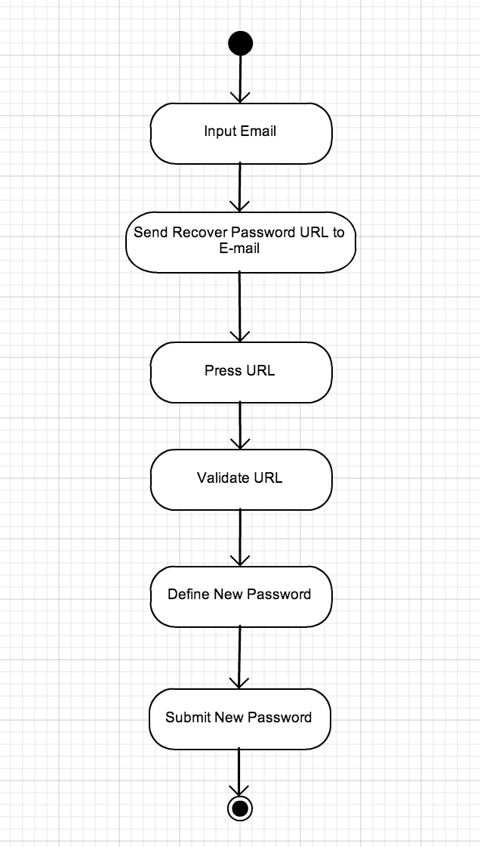

**Figure 4.5:** Activity Diagram of reset password. (AD-005)

**Software Requirement Specification**

**SRS-21:** System shall provide Sign-In interface with sign-in form to receive username, password, “Sign-In” button and “Reset Password” button to the user.

**SRS-31:** System shall provide interface for reset password to receive username as an Email address and “Submit” button.

**SRS-32:** The system shall send the URL for create new password to user’s E-mail address.

**SRS-33**: System shall provide setting the new password page to receive a new password and confirm password.

**SRS-34:** System shall verify a new password and confirm password.

**SRS-35:** System shall update all new information into the server database.

**SRS-36:** System shows the message “Password has been reset”.

**SRS-16:** System shall navigate to Home page for user.

4.1.6 URS-A06: The user can view the user profile.

|  |  |  |
| --- | --- | --- |
| **Use Case Element** | **Description** | |
| Use Case Number : | UC-A06 | |
| Use Case Name : | View profile. | |
| Use Case Description : | Member can view profile that including ID, username, E-mail address, mobile phone, Facebook account, user address and profile picture. | |
| Actor : | Member | |
| Pre-Conditions : | - User already login to the system | |
| Post Conditions : | System shall show page with user information from application database. | |
| Trigger : | User clicks View Profile button on menu bar. | |
| Normal Flow : | Member | System |
| 1 Clicks “Profile” button on menu bar at Main page for member. | 2. System shall navigate to profile page with retrieve the user ID, username, E-mail address, mobile phone, Facebook account, user address and profile picture from the database and show to the user on text field with profile page. |
| Alternative Flow : |  | |
| Exception Flow : |  | |

**Process**

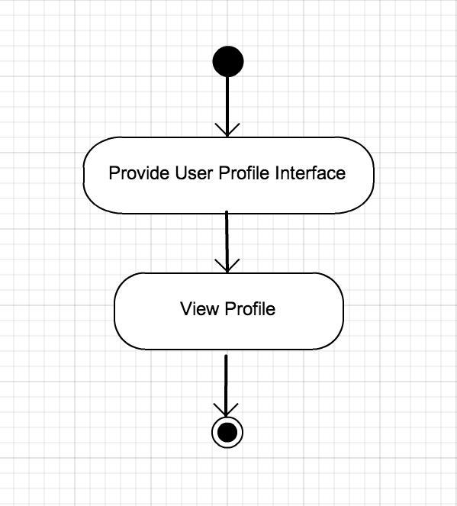

**Figure 4.6:** Activity Diagram of view the user profile. (AD-006)

The activity diagram from the **figure 4.6** presents view the user profile process. The users can view the profile by click on “View Profile” button in the profile page. The system will provide the user information in the application database and show in the user profile interface.

**Software Requirement Specification**

**SRS-37:** System shall navigate to profile page with retrieve the user ID, username, E-mail address, mobile phone, Facebook account, user address and profile picture from the database and show to the user on text field with profile page.

4.1.7 URS-A07: The user can edit profile information.

|  |  |  |
| --- | --- | --- |
| **Use Case Element** | **Description** | |
| Use Case Number : | UC-A07 | |
| Use Case Name : | Edit profile. | |
| Use Case Description : | Member can edit profile that including username, E-mail address, mobile phone, Facebook account and address. | |
| Actor : | Member | |
| Pre-Conditions : | - User already login to the system | |
| Post Conditions : | System shall update information on the application database after edit profile. | |
| Trigger : | User clicks Edit Profile button on Profile page. | |
| Normal Flow : | Member | System |
| 1. Clicks Edit Profile button.  3. User edit user information (username, E-mail address, mobile phone, Facebook account and address)  4. User clicks “Save” button. | 2. System shall navigate to an edit user profile page with retrieve the user information from the application database and allow the user to edit profile information on text field.  5. System shall verify the information  6.System shall update information on the application database.  7. System shall return the message “Update successful”. |
| Alternative Flow : | **4a. If user select Back button.**  4.1 System shall redirect to View Profile page for member.  **5a. If the input email format that is not email format.**  5.1. System shall provide error message “Please enter a valid email address”. | |
| Exception Flow : |  | |

**Table 4:** Present the data which used to input for updating new profile.

|  |  |  |
| --- | --- | --- |
| Data | Example | Note |
| Username | Parun | - length : 2 - 40 characters  - use only : alphabet and space |
| Address | 6/31 Lampang | - length : 10 - 100 characters  - use only : alphabet, number and space |
| Mobile | 02-222-2222 | - length : 9 - 15 characters  - use only : number |
| Facebook | Parun | - length : 2 - 40 characters  - use only : alphabet and number |

**Process**

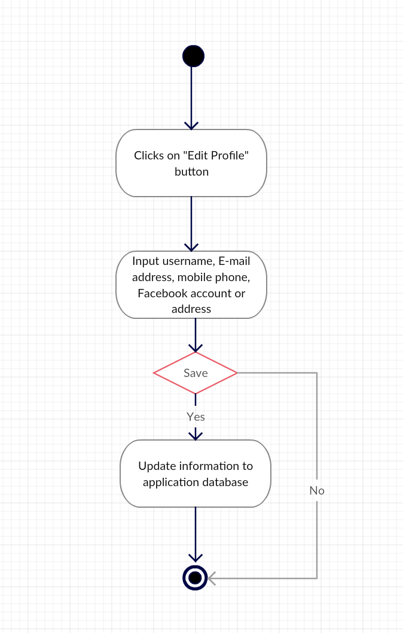

**Figure 4.7:** Activity Diagram of update profile information process (AD-007)

The activity diagram from the **figure 4.7** presents the update profile process. The users click for update the user’s profile. The system provides the form for update the new information. The users can input new information and submit to update into application database.

**Software Requirement Specification**

**SRS-17:** System shall provide Interface to retrieve user information from the application database including ID, username, E-mail address, mobile phone, Facebook account, user address and profile picture, “Edit Profile” button, “Delete User Account” button.

**SRS-38:** System shall navigate to an edit user profile page with retrieve the user information from the application database and allow the user to edit profile information on text field including with username, E-mail address, mobile phone, Facebook account and address and “Save” button.

**SRS-03:** System shall verify all information is completed.

**SRS-05:** System shall verify the input email format that allow email format.

**SRS-14:** System shall provide error message “Please enter a valid email address”.

**SRS-39:** System shall update information on the application database.

**SRS-40:** System shall return the message “Update successful”.

4.1.8 URS-08: The user can change profile picture.

|  |  |  |
| --- | --- | --- |
| **Use Case Element** | **Description** | |
| Use Case Number : | UC-A08 | |
| Use Case Name : | Change profile picture. | |
| Use Case Description : | Member can profile picture | |
| Actor : | Member | |
| Pre-Conditions : | - User already login to the system | |
| Post Conditions : | System shall show new profile picture on the profile page. | |
| Trigger : | User clicks View Profile button on menu bar. | |
| Normal Flow : | Member | System |
| 1 Clicks “Profile” button on menu bar at Main page for member.  3. Click on user profile picture.  5. Click to select new profile picture. | 2. System shall navigate to profile page with retrieve the user ID, username, E-mail address, mobile phone, Facebook account, user address and profile picture from the database and show to the user on text field with profile page.  4. System shall provide interface to access mobile photo library.  6. System shall resize the picture to 150 x 150 (pixel x pixel).  7. System shall set the new profile picture at image layout in the Profile page to present as a new profile picture. |
| Alternative Flow : |  | |
| Exception Flow : |  | |

**Process**

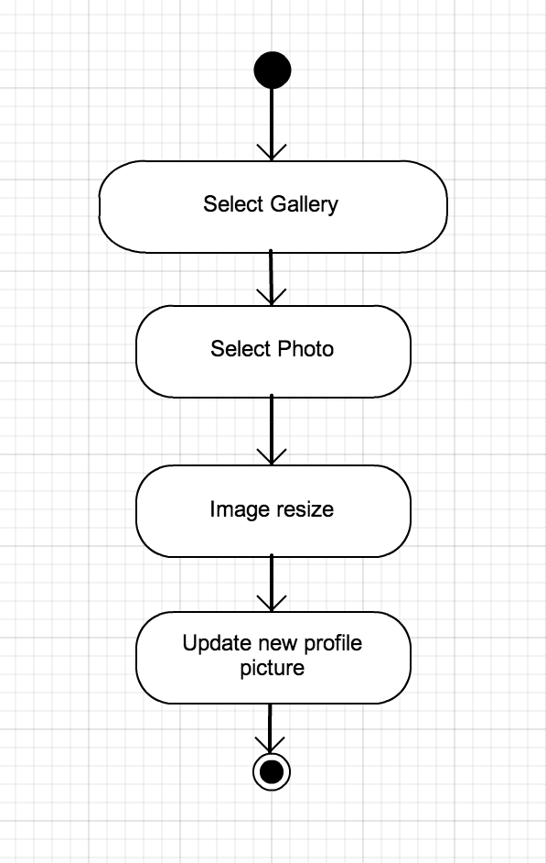

**Figure 4.8:** Activity Diagram of change profile picture process (AD-008)

The activity diagram from the **figure 4.8** presents the change profile picture process. The users click on image view layout on the Profile page for update the user’s profile picture. The system provides the interface for select photo from the form mobile library (internal storage). The users can select one of the photo from the mobile gallery to update a new profile picture.

**Software Requirement Specification**

**SRS-37:** System shall navigate to profile page with retrieve the user ID, username, E-mail address, mobile phone, Facebook account, user address and profile picture from the database and show to the user on text field with profile page.

**SRS-41:** System shall provide interface to access mobile photo library. **SRS-42:**System shall resize the selected photo width and high into 150 x 150 (pixel x pixel). **SRS-43:**System shall set the selected image at image layout in Profile page to present as a profile picture. **SRS-44:** The system shall convert image file type from Bitmap or JPEG to BLOB type. **SRS-45:** The system shall store the new image file into the application database.

4.1.9 URS-A09: The user can view the available map list from the server database via the application.

|  |  |  |
| --- | --- | --- |
| **Use Case Element** | **Description** | |
| Use Case Number : | UC-A09 | |
| Use Case Name : | View map list. | |
| Use Case Description : | Member can view the available map list. | |
| Actor : | Member | |
| Pre-Conditions : | - User already login to the system.  - User already in Main page for member. | |
| Post Conditions : | System shall provide the list-view to show all available map list from the server database. | |
| Trigger : | User clicks on menu tab “Available Map” in Main page for member. | |
| Normal Flow : | Member | System |
| 1. Clicks on “Available Map” menu tab in Main page for member. | 2. System shall provide the list-view to show all available map list from the server database. |
| Alternative Flow : | - | |
| Exception Flow : | - | |

**Process**



**Figure 4.9:** Activity Diagram of view the specified map list view (AD-009)

The activity diagram from the **figure 4.9** presents view the specified map list information process. The users can view all of the specified map list which store in the server database to see more the information and detail. The system provides the interface that presents the map list row to user.

**Software Requirement Specification**

**SRS-46:** System shall connect the server database to retrieve the data of map information. **SRS-47:** System shall provide list-view of all available map information from the server database and present with map picture and map name.

4.1.10 URS-A10: The user can view all of available location title list from the server database via the application.

|  |  |  |
| --- | --- | --- |
| **Use Case Element** | **Description** | |
| Use Case Number : | UC-A10 | |
| Use Case Name : | View location title list. | |
| Use Case Description : | Member can view the available location title list. | |
| Actor : | Member | |
| Pre-Conditions : | - User already login to the system.  - User already in Main page for member. | |
| Post Conditions : | System shall provide the list-view to show all available location title list from the server database. | |
| Trigger : | User clicks on menu tab “Available Title” in Main page for member. | |
| Normal Flow : | Member | System |
| 1. Clicks on “Available Title” menu tab in Main page for member. | 2. System shall provide the list-view to show all available location title list from the server database. |
| Alternative Flow : | - | |
| Exception Flow : | - | |

**Process**



**Figure 4.10:** Activity Diagram of view the specified location text title list view (AD-010)

The activity diagram from the **figure 4.10** presents view the specified location text title list information process. The users can view all of the specified text title list which store in the server database to see more the information and detail. The system provides the interface that presents the map list row to user.

**Software Requirement Specification**

**SRS-48:** System shall connect the server database to retrieve the data of location text title. **SRS-49:** System shall provide list-view of all available location text title from the server database and present with location name.

4.1.11 URS-A11: The user can select one of the specified map from the list to see more detail.

|  |  |  |
| --- | --- | --- |
| **Use Case Element** | **Description** | |
| Use Case Number : | UC-A11 | |
| Use Case Name : | Select one map from list to see more detail | |
| Use Case Description : | Member can select one map from list to see more detail including location name, specified map picture, scanning condition and help information in more detail. | |
| Actor : | Member | |
| Pre-Conditions : | - User already login to the system  - User already is on Main page for member with “Available Map” list tab on menu bar. | |
| Post Conditions : | System shall provide the interface to display all related information of selected map including location name, specified map picture, scanning condition and help information in more detail. | |
| Trigger : | Clicks on one map from list row | |
| Normal Flow : | Member | System |
| 1. Select one map from list. | 2. System shall provide the interface to display all related information of selected map including location name, specified map picture, scanning condition and help information. |
| Alternative Flow : | - | |
| Exception Flow : | - | |

**Process**



**Figure 4.11:** Activity Diagram of selecting the specified map process. (AD-011)

The activity diagram from the **figure 4.11** presents the specified map selecting process. The user can click on specified map target from map list row to see more quest detail with contains location name, specified map picture, scanning condition and help information.

**Software Requirement Specification**

**SRS-46:** System shall connect the server database to retrieve the data of map information. **SRS-47:** System shall provide list-view of all available map information from the server database and present with map picture and map name. **SRS-50:** System shall provide the interface to display all related information of selected map including location name, specified map picture, scanning condition and help information.

4.1.12 URS-A12: The user can select one of the specified title from the list to see more detail.

|  |  |  |
| --- | --- | --- |
| **Use Case Element** | **Description** | |
| Use Case Number : | UC-A12 | |
| Use Case Name : | Select one of the specified title from title list row to see more quest detail | |
| Use Case Description : | Member can select one of the specified title from title list row to see more quest detail including with location name, specified magazine or specified book that use for, scanning condition and help information in more detail. | |
| Actor : | Member | |
| Pre-Conditions : | - User already login to the system  - User already is on Main page for member with “Available Title” list tab on menu bar. | |
| Post Conditions : | System shall provide the interface to display all related information of selected title including with location name, specified magazine or specified book that use for, scanning condition and help information in more detail. | |
| Trigger : | Clicks on one map from list row | |
| Normal Flow : | Member | System |
| 1. Select one text title from list. | 2. System shall provide the interface to display all related information of selected title including with location name, specified magazine or specified book that use for, scanning condition and help information. |
| Alternative Flow : | - | |
| Exception Flow : | - | |

**Process**



**Figure 4.12:** Activity Diagram of selecting the specified map process. (AD-012)

The activity diagram from the **figure 4.12** presents the specified text title selecting process. The user can click on specified text title target from text title list row to see more detail with contains text of the location name, specified magazine or specified book that use for, scanning condition and help information.

**Software Requirement Specification**

**SRS-46:** System shall connect the server database to retrieve the data of map information. **SRS-47:** System shall provide list-view of all available map information from the server database and present with map picture and map name. **SRS-51:** System shall provide the interface to display all related information of selected title including with location name, specified magazine or specified book that use for, scanning condition and help information in more detail.

4.1.13 URS-A13: The user can scan on specified map shape or specified text title to see the related 3-dimension object via the camera.

|  |  |  |
| --- | --- | --- |
| **Use Case Element** | **Description** | |
| Use Case Number : | UC-A13 | |
| Use Case Name : | Scan on target to see the related 3-Dimension object. | |
| Use Case Description : | Member can scan on target to see the related 3-Dimension object via mobile camera. | |
| Actor : | Member | |
| Pre-Conditions : | - User already login to the system.  - User already in Main page for member. | |
| Post Conditions : | System shall provide the interface to scan the specified target. | |
| Trigger : | User clicks on augmented reality button in Main page for member. | |
| Normal Flow : | Member | System |
| 1. Clicks on augmented reality button in Main page for member. | 2. System shall provide the interface to scan the specified target. |
| Alternative Flow : | - | |
| Exception Flow : | - | |

**Process**

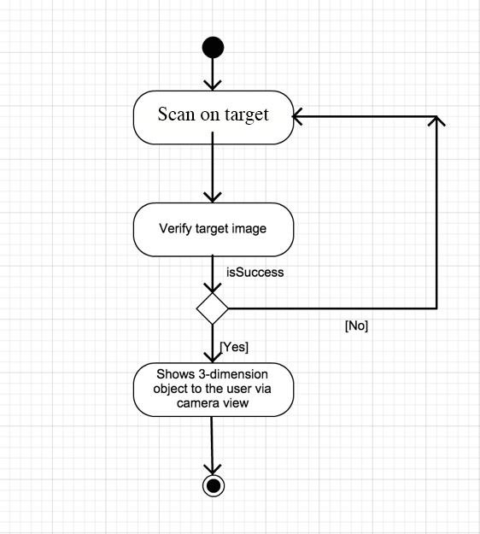

**Figure 4.13:** Activity Diagram of start to play the game process. (AD-013).

**Software Requirement Specification**

**SRS-25:** System shall navigate to Main page for member including menu tab with available map scan list, available text scan list. Home button, Profile button, Augmented Reality button, Map button, Setting button and Search button.

**SRS-52:** System shall provide the interface to scan the specified target. **SRS-53:** System shall verify map shape with the server database. **SRS-54:** System shall verify location text title with the server database. **SRS-55:** The system shall provide an asset folder in the application to provide .XML and .DAT files. **SRS-56:** The system shall render and generate 3-dimension and display the on the camera view.

4.1.20 URS-W01: The administrator can login into the web application system.

|  |  |  |
| --- | --- | --- |
| **Use Case Element** | **Description** | |
| Use Case Number : | UC-W01 | |
| Use Case Name : | Login | |
| Use Case Description : | Admin have to login to the system for using features for administrator that including Home menu, Management, Edit Profile, Location, Add Location. | |
| Actor : | Administrator | |
| Pre-Conditions : | - User already in Index page.  - User already have admin account to login to the system | |
| Post Conditions : | - User can use features for admin. | |
| Trigger : | - User select “Login” link. | |
| Normal Flow : | Administrator | System |
| 1. Select Login link  3. User input username and password  4. User select “login” button | 2. System shall provide login page with login form to receive username, password and login button from the user.  5. System shall verify username and password.  6. System shall redirect to Home home page for admin. |
| Alternative Flow : | **5a.If username and password are not completed.**  5.1 System shall provide error message “This field is required”  **5b.If username and password are not match with database..**  5.2 System shall provide error message “Login information is not valid”. | |
| Exception Flow : | - | |

**Table 6:** Present the data which used to input for login to the system.

|  |  |  |
| --- | --- | --- |
| Data | Example | Note |
| Username | [parun@hotmail.com](mailto:parun@hotmail.com) | - length : 10 - 254 characters  - format : email format |
| Password | parun | - length : 6 - 15 characters  - use only : alphabet or number |

**Process**



**Figure 4.20:** Activity Diagram of login to the system (AD-020)

The activity diagram from the **figure 4.20** presents the login process. The user can login via system account by inputting username and password. If login to the system successful, the system will give the user authorization.

**Software Requirement Specification**

**SRS-57:** System shall provide Index page with login link on menu bar.

**SRS-58:** System shall provide login page with login form to receive username, password and login button to the user.

**SRS-59:** System shall verify username and password with the server database.

**SRS-60:** System shall verify username and password are completed.

**SRS-61:** System shall provide error message “This field is required”

**SRS-62:** System shall provide error message “Login information is not valid”.

**SRS-63:** System shall give an authorization for the user to administrator.

**SRS-64:** System shall redirect to Home page for administrator that including menu tab of administrator Home, Management, Edit Profile, Location, Add Location.

4.1.21 URS-W02: The administrator can logout from the web application system.

|  |  |  |
| --- | --- | --- |
| **Use Case Element** | **Description** | |
| Use Case Number : | UC-W02 | |
| Use Case Name : | Logout | |
| Use Case Description : | Admin can logout from the system and return status to be general user. | |
| Actor : | Administrator | |
| Pre-Conditions : | - User already login to the system | |
| Post Conditions : | System shall clear user session.  System shall redirect to Index page for general user | |
| Trigger : | - User select “Logout” button | |
| Normal Flow : | Administrator | System |
| 1. Select Logout link. | 2. System shall clear user session.  3. System shall redirect to Index page for visitor |
| Alternative Flow : | - | |
| Exception Flow : | - | |

**Process**



**Figure 4.21:** Activity Diagram of delete user account (AD-021)

The activity diagram from the **figure 4.21** presents the logout process. The admin can click for logout from the system. The system will remove the admin authorization and admin identity.

**Software Requirement Specification**

**SRS-65:** System shall provide Logout link on menu bar. **SRS-66:** System shall clear user session.

**SRS-67:** System shall redirect to Index page for visitor.

4.1.22 URS-W03: The Administrator can add the new location information into the server.

|  |  |  |
| --- | --- | --- |
| **Use Case Element** | **Description** | |
| Use Case Number : | UC-W03 | |
| Use Case Name : | Add a new location | |
| Use Case Description : | Administrator can add a new location into the server. | |
| Actor : | Administrator | |
| Pre-Conditions : | - User already login to the system as administrator.  - User already is on add new location page. | |
| Post Conditions : | System shall record all information into database. | |
| Trigger : | User Clicks on **Add Location** button | |
| Normal Flow : | Administrator | System |
| 1. Select Add Location button  3. User input information.  4. User clicks on Submit button. | 2. System shall provide add new location forum to receive new location information as text field (Location Name, Description, Map ID, Location Status, Location Province, Location Text Title) and upload field (Location Map Picture as .jpeg or .png, Location Map 3D object file as .obj), brown and submit button.  5.System shall verify input information.  6.System shall record all information into server database.  7. System shall provide message “Add New Location Successful”  8. System shall return to add new location forum page. |
| Alternative Flow : | **3a. If user select Cancel button.**  3.1. System shall redirect to User forum page.  **5a. If title name or picture name or post detail is empty.**  5.1 System shall provide error message “ **This field is required** ” on each text field. | |
| Exception Flow : |  | |

**Table 7:** Present the data which used to input for login to the system.

|  |  |  |
| --- | --- | --- |
| Data | Example | Note |
| Username | [parun@hotmail.com](mailto:parun@hotmail.com) | - length : 10 - 254 characters  - format : email format |
| Password | parun | - length : 6 - 15 characters  - use only : alphabet or number |

**Table 8:** Present the data which used to input for adding the new location information to the server database.

|  |  |  |
| --- | --- | --- |
| Data | Example | Note |
| l_name | Chiang Mai | - length : 10 - 254 characters  - use only : alphabet or number |
| l_image | Chiangmai.jpg | - BLOB |
| l_description | Chiang Mai province map shape | - length : 10 - 254 characters  - use only : alphabet or number |
| l_total_province | Chiang Mai province | - length : 6 - 15 characters  - use only : alphabet or number |
| l_status | 1 | - Integer |
| l_model_object | hotel.obj | - BLOB |

**Process**

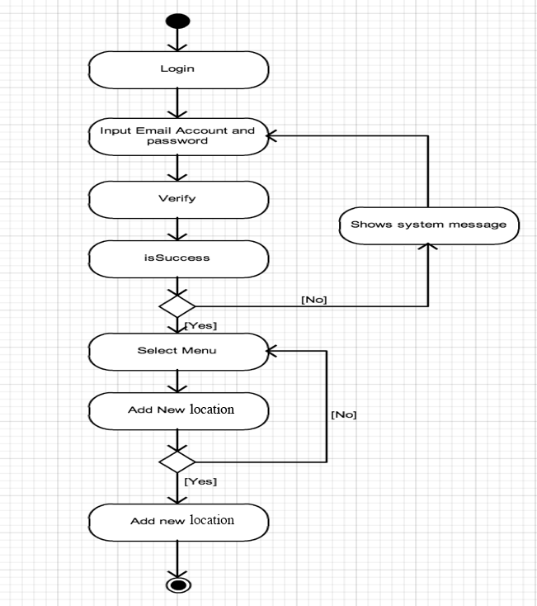

**Figure 4.22:** Activity Diagram of administrator can add the new location information into server database. (AD-022)

The activity diagram from the **figure 4.22** presents adding the new location information by the administrator into server database process. The Administrator can add the new location information into the server with location name, location image, description and status mapping with Vuforia online database. After complete, it will available and show to the user.

**Software Requirement Specification**

**SRS-68:** System shall provide forum button on profile menu and forums link on menu bar.

**SRS-69:** System shall provide add new location forum to receive new location information as text field (Location Name, Description, Map ID, Location Status, Location Province, Location Text Title) and upload field (Location Map Picture as .jpeg or .png, Location Map 3D object file as .obj), brown and submit button.

**SRS-70:** System shall verify input information (Location Name, Description, Map ID, Location Status, Location Province, Location Text Title) and upload field (Location Map Picture as .jpeg or .png, Location Map 3D object file as .obj) cannot empty

**SRS-71:** System shall record all information into the server database.

**SRS-72:** System shall provide message “Add New Location Successful”

**SRS-73:** System shall return to add new location forum page.

**SRS-61:** System shall provide error message “This field is required”